**CS 436 - Final Exam Study guide**

Your final exam contains the following topics:

1. HW assignment3 (Subnetting): Lecture 9
2. HW assignment4:
   1. IP fragmentation, checksum: Lecture 13
   2. NAT: Lecture 15
   3. IP and MAC addresses in public and private networks: Lectures 15 and 16
   4. Switch tables: Lecture 16

1. Textbook topics covered in the lectures 9-20. Some sample questions are as follows.

1. Suppose you are at CSUSM campus and within your Web browser click on a link to obtain a Web page at cs.palomar.edu (destination). The IP address of the associated URL is not cached in your local host, so a DNS lookup is necessary to obtain the IP address. The DNS server name at CSUSM is **atlas.csusm.edu**. The DNS server’s name at Palomar College is **ns1.palomar.edu**. Draw a picture that displays the steps taken by your browser and all other systems involved in **DNS protocol** starting from the moment your browser requests the destination’s IP address until it receives the IP address. Start from your system; display and name the referenced DNS servers on the picture; number each step on the picture; briefly explain each step. Lecture 14, slide 15. Also notice that if your browser has already cached the required IP, it resolves the IP using its own cache; Otherwise, If your local DNS server has already cached the required IP, it resolves the IP using its own cache; Otherwise, If your local DNS server has already cached the IP of authoritative DNS server, it directly asks the authoritative DNS server without referring to other levels of DNS servers, such as root or TLD servers.

1. Assume in your browser, you click on a link that opens a webpage containing 3 other small objects stored on the same server. Draw a picture that demonstrate the messages exchanged between client and server to get the base HTML file and the 3 objects assuming the browser uses non-persistent HTTP that allows 3 parallel connections. Draw a similar picture for persistent HTTP where the requests for objects are sent back-to-back in a pipeline. Start from TCP connection establishment, show the steps of HTTP protocol and finally closing the TCP connection. How many RTTs are required to get the HTML file and included objects in each scenario? Note that this time starts from the moment your system starts establishing a connection with the server until you receive all the objects. The time required for the final ACKs and close the connection are not part of that. Lecture10, slides 12, 13

1. What are the benefits of using DHCP? Name 4 benefits and briefly explain each. Lecture 11, slide 5

It allows reuse of addresses, a node will only hold the address while connected and it can be used by other user when released; it supports mobile users who want to join network for a short time; the DHCP server has a pool of available IP addresses, an address is assigned to an user and return to the pool on leave; the number of used IP addresses at each moment is less thn the total number of users because many of them are not connected at that moment.

1. What are the 4 pieces of information that DHCP server sends to a node once it accepts the node’s request to join the network? Lecture 11, slide 9

It sends the allocated IP address to the node, the first-hop router IP address, name and IP address of DNS server and the subnet mask.

1. Compare IP and MAC addresses in four aspects. 1. In what layer they are used. 2.

Length. 3. Flat or hierarchical. 4. The way they are assigned to the node’s interface. Lecture 16

IP is used on network layer and MAC address is used on Link layer; IP has a 32-bit length and MAC has 48-bit length; IP is hierarchical and MAC is flat. The IP address changes with node, because is defined by the subnet within it, the mac address is burnt onto the computer NIC card.

1. Why ARP protocol is called a plug and play protocol? Assume nodes A and B are at the same network. Node A has recently joined the network and its ARP table is empty. Now assume source node A wants to send data to destination node B, what are the 3 steps ARP protocol takes at node A? What is the purpose of these steps? (What information is required that is not initially available at node A’s ARP table? Why node A needs that? What does it do with that?) Lecture 16, slide 10

The ARP protocol is called a plug and play protocol because the node simply creates the ARP without net-administrator intervention; It sends a request to find B’s address, B replies, and A stores the value in the table. So the 3 steps are send and receive message and store the destination; The purpose of it is to identify the destination address and check if the destination is on the same subnet, the information previously unknown and necessary to A’ s ARP table is the B Mac address. It encapsules the message with the Destination Mac address on its header at the link layer before transmiting it on the network.

1. When a frame arrives at switch, how does the switch figure out what is the proper outgoing port number to forward the frame? Explain the steps with details. Lecture 16, slide 31

It checks its MAC address table, if there is an entry on it, then the switch forwards the frame out the associated port via a unicast message; otherwise, it forwards the frame to all its ports, except the one it has received the frame.

1. What are the four benefits of using UDP vs TCP? Lecture 18, slide 7

UDP doesn’t establish a connection; there’s no connection between a UDP sender and a receiver; each UDP segment is handled independently of others; UDP is consider a best-effort service.

1. What does RTT stand for? Define it. Explain why we need to estimate it? What is the formula to estimate it? Briefly explain the formula. Expand the formula for two steps to estimate RTT10. Lecture 18, slides 26-29

RTT stands for Round Trip Time, which is the time it takes for message to be sent plus the time to receive an acknowledgement message for it. We need to estimate it to better optimize communication over network by: defining the standard time it takes usually to receive an acknowledgement for a message sent to be able to infer that a message may have been lost during propagation. The formula consists of determing the RTT for the current message based on the previous message RTT estimation multiplied by one minus a definid weight plus the real time it took for the previous message times the weight; briefly, Estimated Time of *I* = ET*i-1* * (1 - weight) + STi-1*(weight). For RTT10, it would be:

RTT10 = ET9* (1- w) + S9(w) =>( ET8*(1-w) +S8(w)) *(1-w) +S9(w)

So RTT10 is equal to ET8 * (1-w)² + (1-w)*w*S8 + S9*w

1. What are the two types of link-layer channels? Briefly explain each. Give two examples of each type. Lecture 19, slide 5

Point-to-Point and Broadcast; PTP is a link between a host an a router or a link in-between to routers, and broadcast is a multiple-host-one-router link or a wireless router with various computers connected.

1. Where is each of the five layers implemented in? Application, Operating system, or NIC? Lecture 19, Slide 10

Application layer is implemented on application, Transport and Network at Operating System, the Link is on OS or NIC, and the Physical is on NIC.

1. What is the challenge of a shared broadcast channel? Briefly explain the challenge and the undesired results of that. Lecture 19, slide 17

To avoid collisions, because in a collision all the data received is corrupted and the result of that is lost channel bandwidth.

1. Describe 4 aspects of an ideal multiple access protocol. Lecture 19, slide 18

It should transmit packets at full channel data rate; shouldn’t have a coordination among nodes a priori; it should know how to detect collisions and how to recover from them.

when one node wants to transmit, it can send at rate R.

2. when M nodes want to transmit, each can send at average rate R/M

3. the protocol is fully decentralized:

* + - no special node to coordinate transmissions
    - no synchronization of clocks, time slots
    - no master node that represents a single point of failure

4. the protocol is simple, so that inexpensive to implement

1. What are the 3 classes of MAC protocols for shared broadcast channels? Name and briefly explain each one. Give three examples for each class. Compare them and explain why three different classes have been proposed. Lecture 19, slides 19, 20

--WRONG MAYBE

FDMA, Frequency Division Multiple Access, it sends information through one of various frequency bands, unused bands go idle; TDMA, Time Division Multiple Access, it sends the defined chunks of information via a defined time round. Carrier Sense Multiple Access, it sends entire packet when no one is using the channel, otherwise it defers the transmission.

1. **For each MAC protocol, you should be able to explain what is the average bandwidth accessible over time for each user if there is one active user who has data to transmit. And also answer the same question if there are N active users. In some algorithms, it may not be possible to get an exact number. In such cases, you should be familiar enough with the algorithm to come up with an approximate value in a given scenario. For example whether the bandwidth is R/N or less than that for a given scenario**

**-**

**-WRONG MAYBE**

**FDMA, for 1, rate is R, for M, rate is R, because of bands many users can transmit at a R rate at the same time or when alone. TDMA, for 1, rate is R, for M rate is R/m for every user. CDMA,**

1. Explain and compare TDMA and FDMA with examples. Lecture 19, slides 21, 22

TDMA divides the incoming packets to be propagated into rounds of transmission, where chunks of packets’ data are propagated within a defined time and, when it expires, the next chunk waiting is propagated. With FDMA, every incoming packet has a bandwidth channel frequence defined in which it will propagate is data, if the channel is not used, then it remains idle. The bandwidth rate in FDMA is invariable rate R over the number of channel; for TDMA, it is R for one host and R / m for m hosts.

1. Explain how Slotted ALOHA protocol works. What are the pros and cons of this protocol? The exam question may ask about more details. Lecture 19, slides 25, 26

The pros of it are a single active node can continuously transmit at full rate of channel,

highly decentralized: only time-slots in nodes need to be in sync and it’s simple; the cons of it are collisions, wasting slots and idle slots, nodes may be able to detect collision in less than time to transmit packet and clock synchronization.

1. Explain and compare Polling and Ring MAC protocols with examples. The exam question may ask about more details. Lecture 19, slides 32, 33

In polling, a master nodes invites a slave node to transmit in turn, it’s used typically used with dumb slave devices, it generates polling overhead and latency, it’s single point of failure is the master; in Ring, a token is passed from one to another sequentially, it generates token overhead and latency, it’s single point of failure is the token.

1. Draw a picture that shows even though nodes sense the channel before transmission, collisions may still occur in CSMA protocol. What is the reason? How could you reduce the channel wastage? Explain the solution and show it on the picture. Lecture 19, slides 28-30

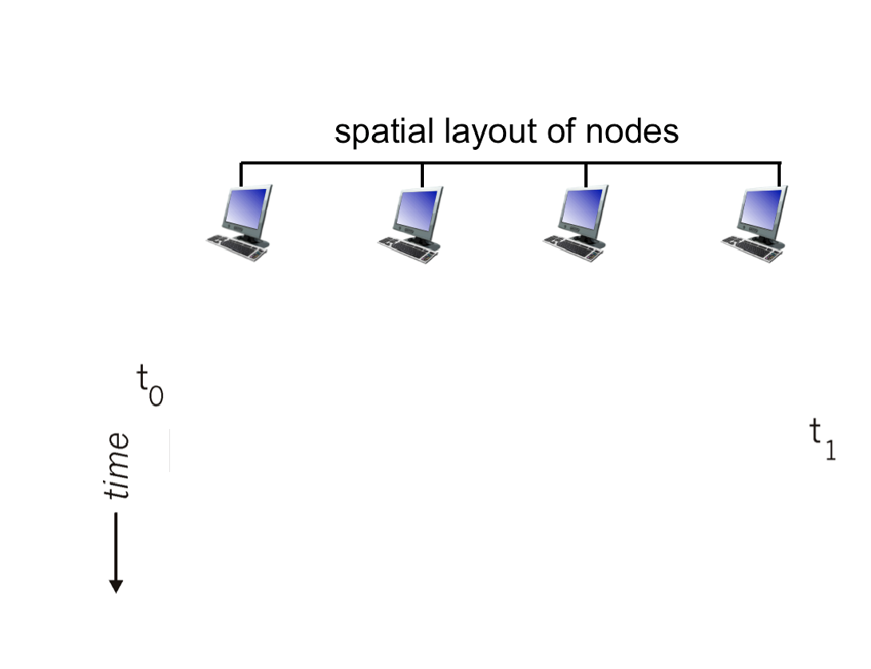

1. Assume a node arrives at a LAN. The DHCP server IP address is 145.62.35.48. Assume transaction ID for the first message is 555. Fill in the blanks in the picture below (4*4=16 items).

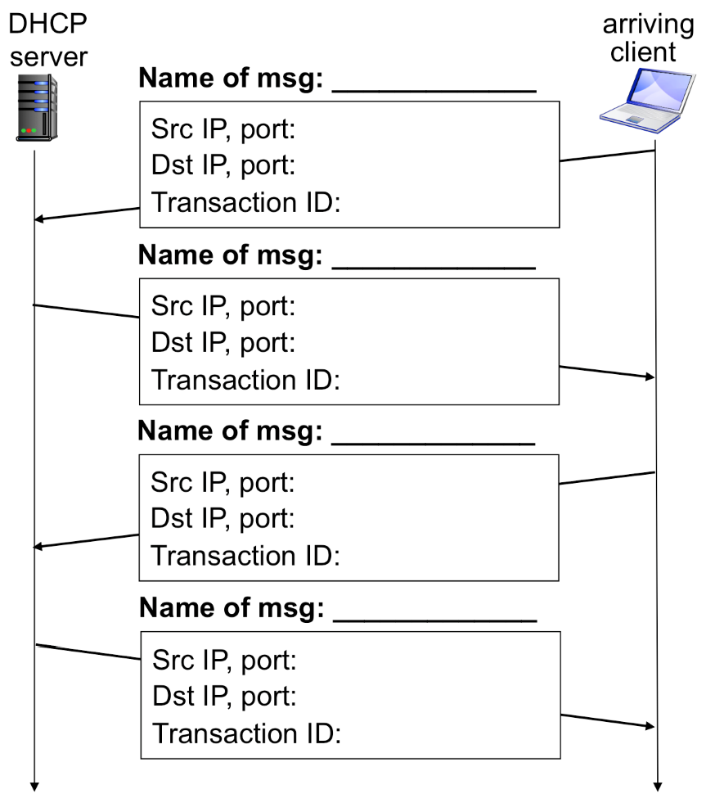

1. Draw the three messages exchanged between client and server for 3-way handshake connection establishment. Choose **x** for init seq number at client, and **y** at server.

Specify seq num, ack num and the bits set at each step. Lecture 18

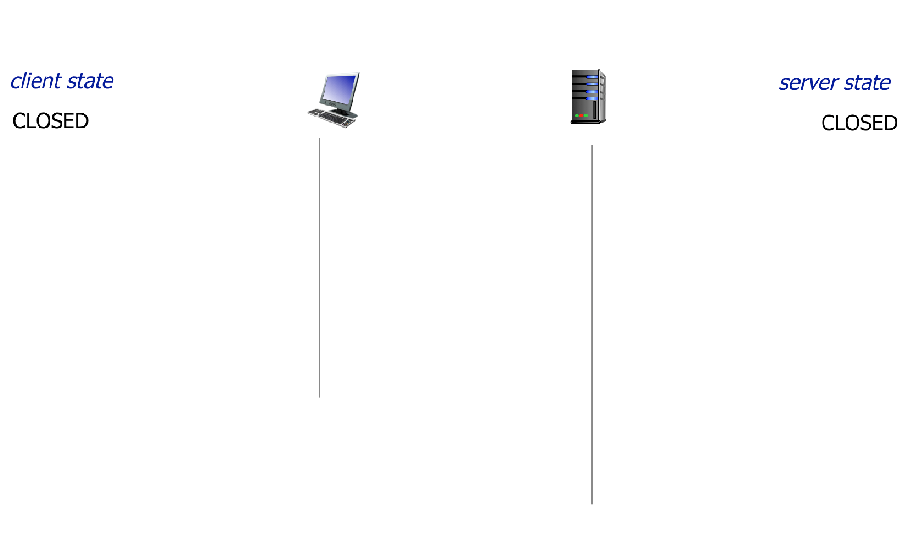

1. Draw the messages exchanged between client and server for closing a TCP connection. Choose **x** for current seq number at client, and **y** at server. Specify seq num, ack num and the bits set at each step. Lecture 18

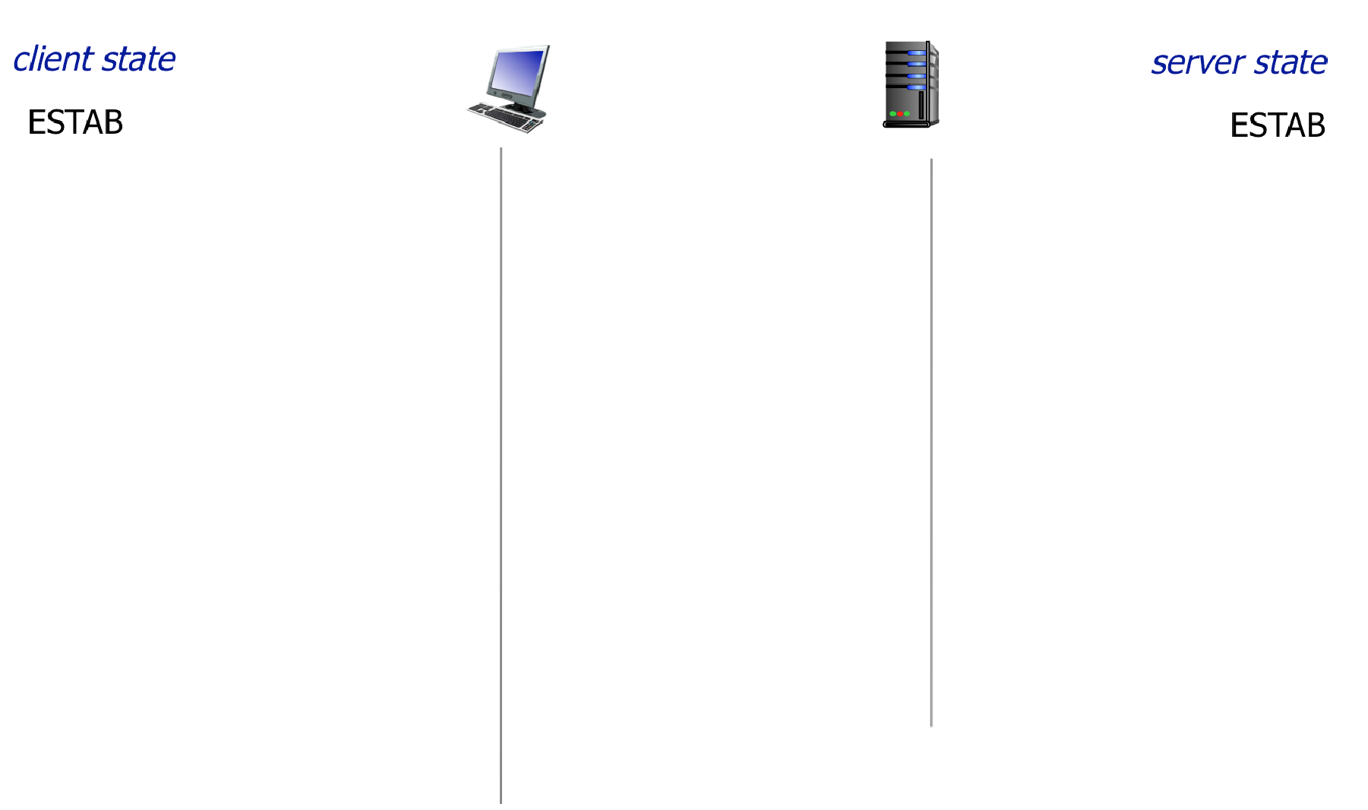

1. Describe the 4 types (A, B, C, D) of byte streams at the TCP sender memory space whether they are sent, ACKed, usable or not. In what case we move the buffer to the right? Lecture 18

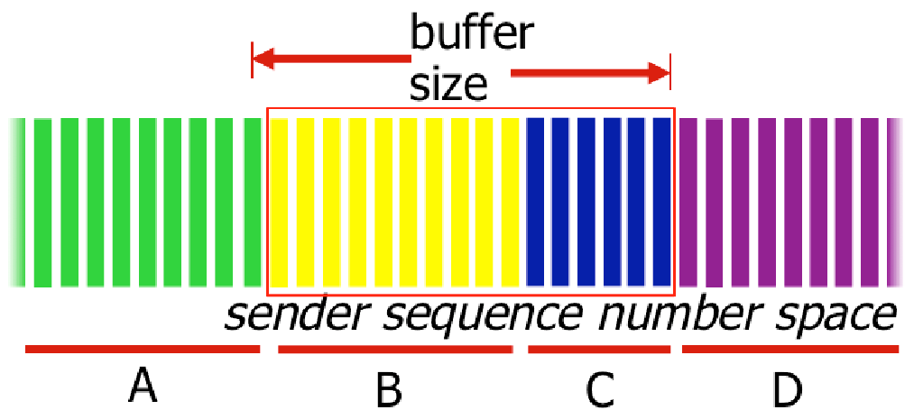

1. In the picture below, specify the location of client and server send and receive buffers. Draw arrows between client’s process and server’s process s.t. the arrows pass the correct socket, buffer, and lower layers and reach the destinations. Lecture 18

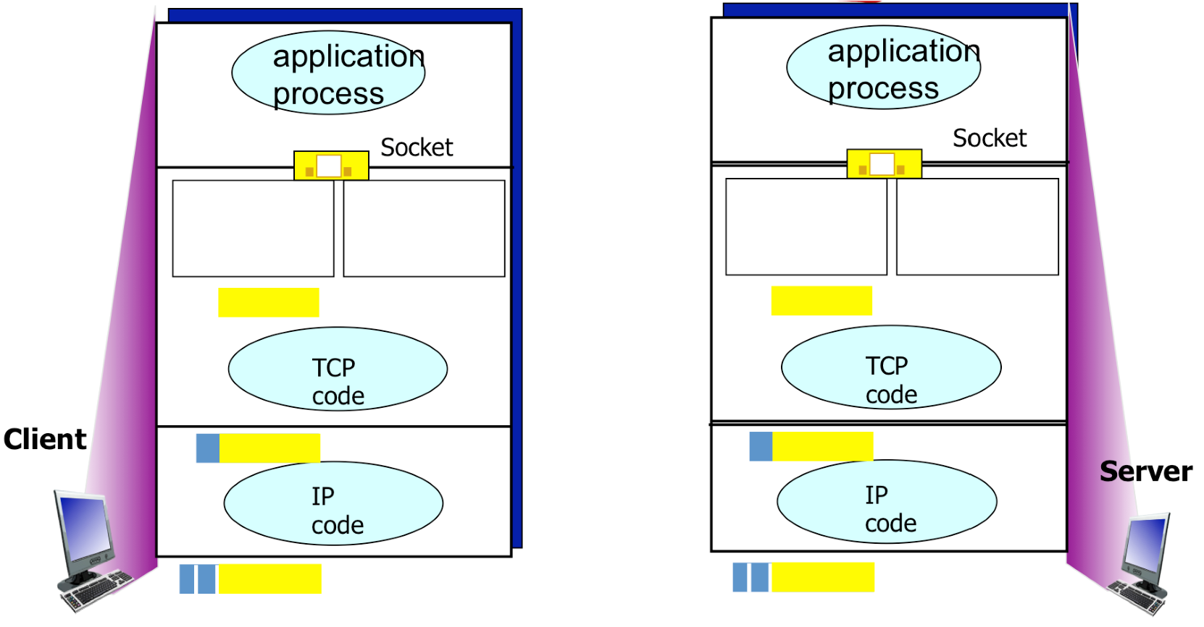

1. Assume the buffer size is 5 slots. The size of each slot is 1 Kbits data. Note that we only consider the size of data without any header. Also, only the data is stored in the buffer. Assume the traffic generator at the source has 20 packets to send and has numbered them from 0 to 19.

a. At each step, the sender transmits as many packets as possible. In the following picture, draw a rectangle to show the TCP send buffer after sending the first sequence of packets. The numbers indicate the packet numbers. Also, if there are packets that have been sent but not Acked yet, highlight them.

|  |  |  |  |  |  |  |  |  |  |  |  |  |  |  |  |  |  |  |  |
| --- | --- | --- | --- | --- | --- | --- | --- | --- | --- | --- | --- | --- | --- | --- | --- | --- | --- | --- | --- |
| 0 | 1 | 2 | 3 | 4 | 5 | 6 | 7 | 8 | 9 | 10 | 11 | 12 | 13 | 14 | 15 | 16 | 17 | 18 | 19 |

**Note that this question might have next steps. You should study Lecture18 slide 25, and watch the given video to get familiar with such scenarios and be able to answer this type of questions.**